**Task 1**

In this first task, Little Lemon need you to create a procedure that displays the maximum ordered quantity in the Orders table.

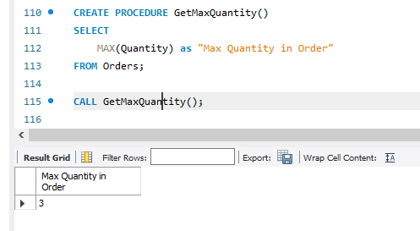

## ****Task 2****

In the second task, Little Lemon need you to help them to create a prepared statement called **GetOrderDetail**. This prepared statement will help to reduce the parsing time of queries. It will also help to secure the database from SQL injections.

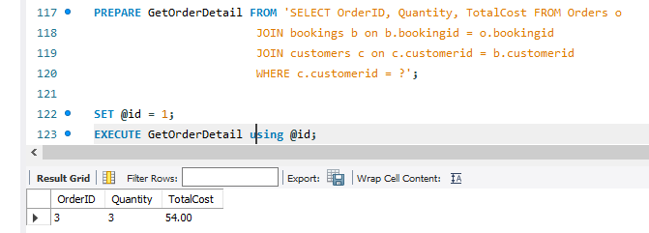

## ****Task 3****

Your third and final task is to create a stored procedure called **CancelOrder**. Little Lemon want to use this stored procedure to delete an order record based on the user input of the order id.

Select statement before executing the Stored Procedure:

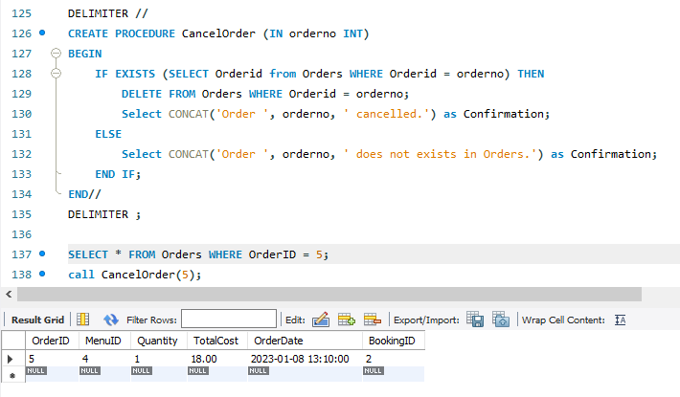

Result of the Stored Procedure:

